Table of Contents

AZURE MANAGEMENT AND GOVERNANCE 2

COST MANAGEMENT 2

PRICING STRUCTURE 2

PRICING FACTORS 3

AZURE BILLING ZONES 3

PRICING CALCULATOR 3

TOTAL COST OWNERSHIP CALCULATOR 4

BEST PRACTICES – COST MANAGEMENT 4

BUDGETS 5

RESOURCE TAGS 7

GOVERNANCE AND COMPLIANCE 8

AZURE SUPPORT PLANS 8

AZURE SERVICE LEVEL AGGREMENT 9

SERVICES IN PREVIEW 10

MICROSOFT CLOUD ADOPTION FRAMEWORK 10

SERVICE TRUST PORTAL 11

MOVING RESOURCES ACROSS RESOURCE GROUPS 12

MOVING RESOURCES ACROSS SUBSCRIPTIONS 12

LOCKING RESOURCES 13

AZURE POLICY 14

MANAGEMENT GROUP 15

# AZURE MANAGEMENT AND GOVERNANCE

## COST MANAGEMENT

### PRICING STRUCTURE

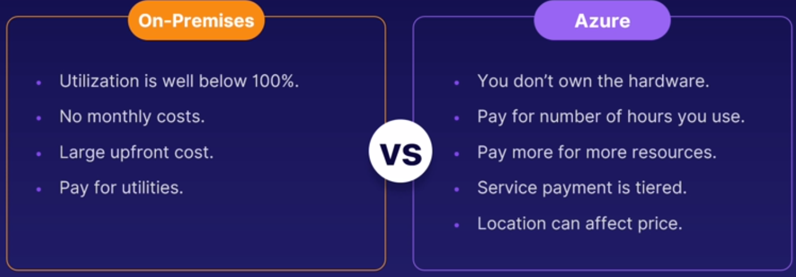

* Azure Cost Management is a tool provided by Microsoft that helps organizations monitor, manage, and optimize their Azure cloud costs.
* It enables users to gain insights into their usage and spending, identify cost-saving opportunities, and set budget and spending limits.
* The Cost Management tool is completely free of charge for all subscription types

KEY FEATURES AND FUNCTIONALITIES OF AZURE COST MANAGEMENT:

* COST VISIBILITY
  + Azure Cost Management provides a comprehensive view of your Azure spending and usage across subscriptions, resource groups, and services. It offers detailed reports, dashboards, and interactive charts to visualize and analyze your cost data.
* COST ANALYSIS
  + The tool enables you to analyze your Azure costs by different dimensions such as resource type, region, and tags. It helps you identify cost drivers and optimize spending by understanding which resources are consuming the most resources and incurring the highest costs.
* BUDGETING AND ALERTS
  + Azure Cost Management allows you to set budget limits for your Azure spending and receive alerts when you approach or exceed those limits. It helps you proactively manage your costs and avoid unexpected overages.
* COST OPTIMIZATION RECOMMENDATIONS
  + The tool provides recommendations to optimize your Azure costs based on your usage patterns and resource configurations. These recommendations can include rightsizing virtual machines, deleting unutilized resources, or switching to reserved instances for cost savings.
* AZURE ADVISOR INTEGRATION
  + Azure Cost Management integrates with Azure Advisor, which provides intelligent recommendations for improving the performance, security, and reliability of your Azure resources. This integration helps you make informed decisions that balance cost optimization with other important considerations.
* COST ALLOCATION AND CHARGEBACK
  + Azure Cost Management allows you to allocate costs to different departments, teams, or projects within your organization.

### PRICING FACTORS

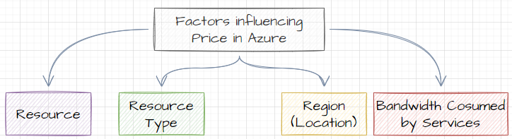

### AZURE BILLING ZONES

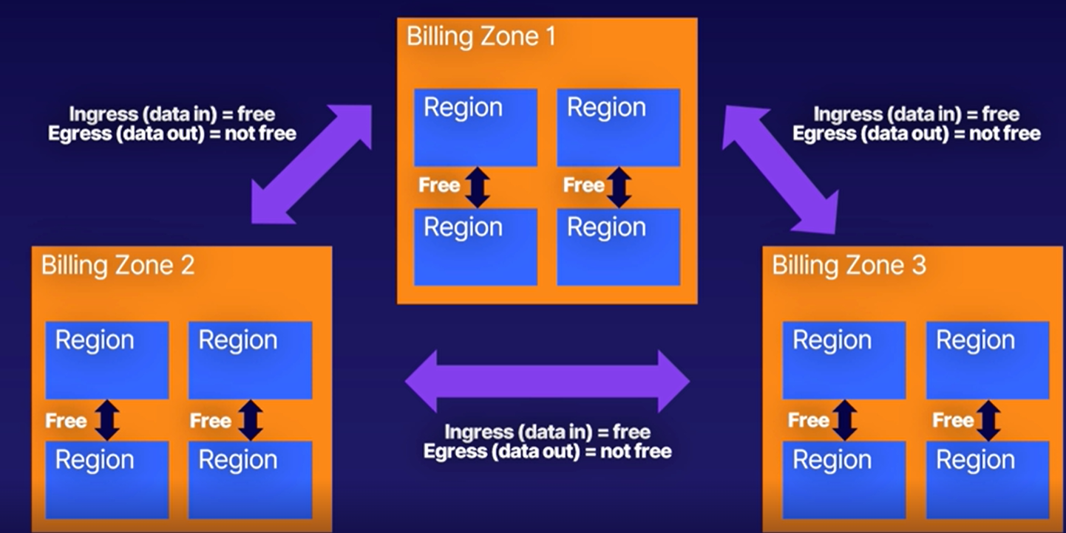

* Azure has three billing zones in the world and each of these zones include many Azure regions.
* Any data transfer between Azure services located in the same zone is free.
* Any data transfer between two different billing zones is charged. This is also called ingress, data in, and egress, data out, data. ***Ingress data is always free, but egress data (so that's data going out) has a cost with it when it is transmitted between two different billing zones.***

### PRICING CALCULATOR

* The Azure Pricing Calculator is a tool provided by Microsoft Azure that allows us **to estimate and calculate the costs of using various Azure services and resources**.
* It helps us to understand the pricing structure and provides an estimate of the monthly costs based on our usage requirements.
* URL : <https://azure.microsoft.com/en-us/pricing/calculator/>

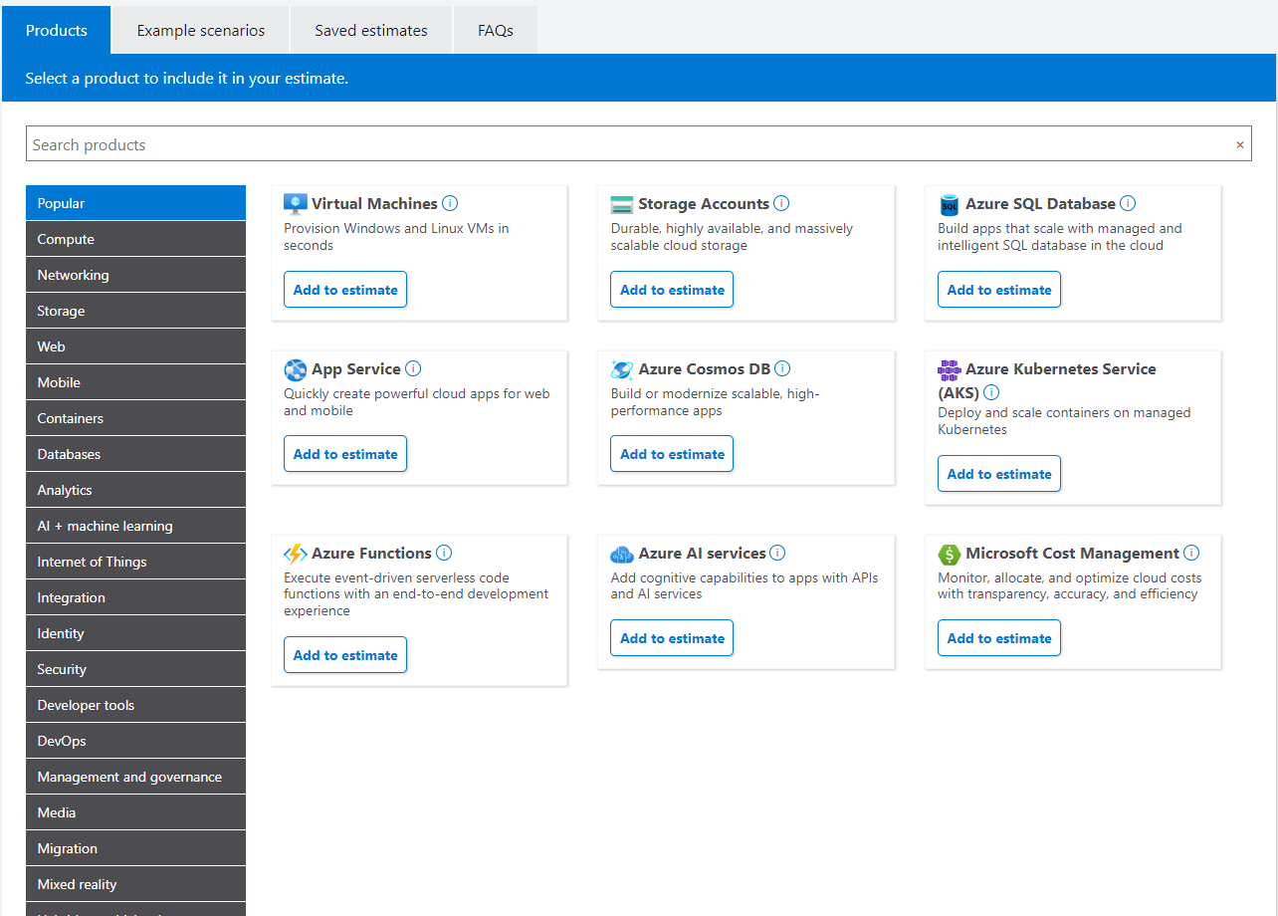

### TOTAL COST OWNERSHIP CALCULATOR

* The Total Cost of Ownership (TCO) Calculator is a tool that helps organizations estimate the overall costs associated with implementing and operating a particular technology solution or system over a defined period.
* TCO considers the upfront costs but also the ongoing expenses, maintenance, and support costs.
* Microsoft offers a TCO Calculator specifically for comparing the costs of running workloads on-premises versus in the cloud using Azure. This tool helps organizations assess the potential cost savings and benefits of migrating their infrastructure or applications to Azure.
* URL : <https://azure.microsoft.com/en-us/pricing/tco/calculator/>

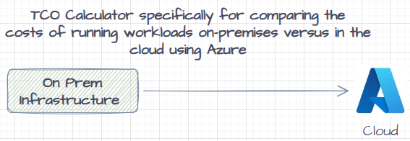

### BEST PRACTICES – COST MANAGEMENT

1. SET BUDGET LIMITS
   1. Establish budget limits to control the Azure spending.
   2. Set realistic budgets based on historical data and adjust them as needed.
   3. Azure Cost Management allows us to set budget alerts to receive notifications when we approach or exceed our defined spending limits.
2. RIGHTSIZE RESOURCES
   1. Continuously evaluate the resource usage and right-size the virtual machines and other Azure resources.
   2. Downsizing or using lower-cost alternatives can significantly reduce costs while still meeting the performance requirements.
3. LEVERAGE RESERVED INSTANCES
   1. Utilize Azure Reserved Virtual Machine Instances for predictable workloads with long-term commitments.
   2. Reserved Instances provide substantial cost savings compared to pay-as-you-go rates.

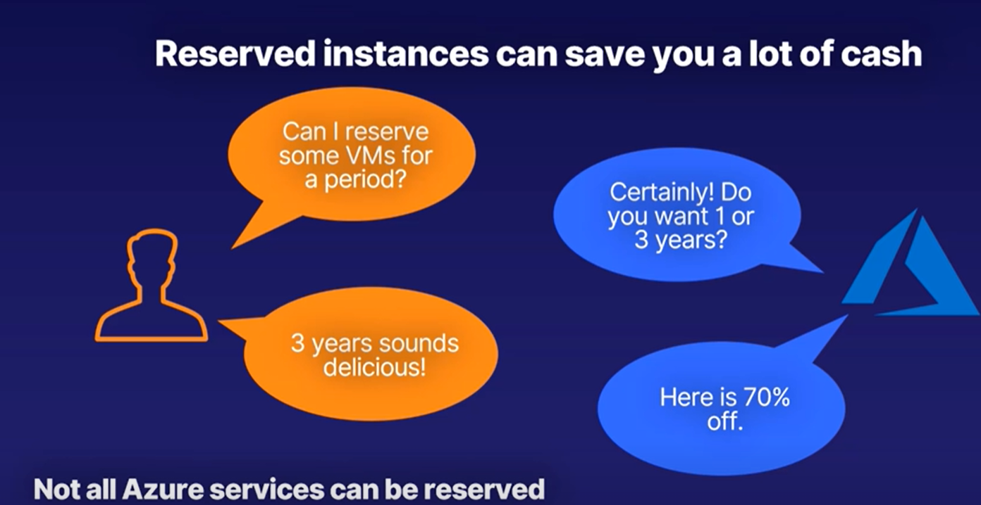

1. USE AZURE HYBRID BENEFIT
   1. If we have active software assurance, take advantage of the Azure Hybrid Benefit to save on Windows Server and SQL Server licensing costs when running them in Azure.
2. OPTIMIZE STORAGE COSTS
   1. Optimize the Azure storage costs by regularly reviewing and deleting unused or unnecessary data.
   2. Utilize features like Blob Storage lifecycle management to automatically move or delete data based on defined policies.
3. UTILIZE SERVERLESS TECHNOLOGIES
   1. Consider leveraging serverless technologies like Azure Functions or Logic Apps for certain workloads.
   2. Serverless offerings scale dynamically and can be more cost-effective for sporadic or low-traffic workloads.
4. TAKE ADVANTAGE OF SPOT INSTANCES
   1. Consider using Azure Spot Virtual Machines for fault-tolerant workloads that can handle interruptions. Spot VMs offer significant cost savings compared to regular on-demand pricing.
5. IMPLEMENT RESOURCE TAGGING:
   1. Implement consistent and meaningful resource tagging practices.
   2. Tags can help you track and categorize costs by department, project, or other criteria, making it easier to allocate costs and identify areas for optimization.
6. REGULARLY REVIEW AND OPTIMIZE
   1. Continuously review and optimize your Azure resources, services, and spending.
   2. Regularly assess your environment, apply cost optimization recommendations provided by Azure Advisor, and stay up to date with the latest cost management best practices.

### BUDGETS

* In Azure, budgets are a feature that allows us **to set spending limits and receive notifications when the usage or costs exceed the defined thresholds**.
* Budgets help us in monitoring and managing Azure spending to avoid unexpected expenses and maintain control over resources.

#### CREATING BUDGETS

* Go to subscription 🡪 Budget 🡪 Add Budgets
* In the below example we are creating a budget that will send an email notification when the cost reaches the 80% (**6400**) of the budget amount (**8000**)

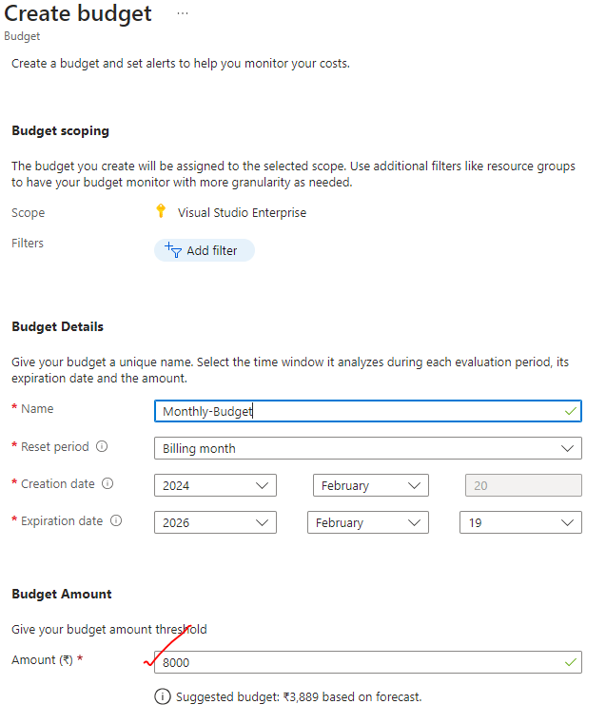

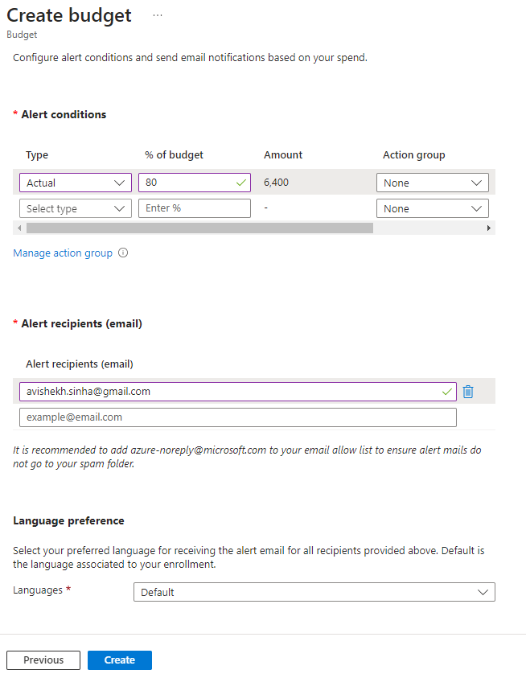

### RESOURCE TAGS

* In Azure, resource tags are metadata that we can assign to resources to organize and categorize them.
* Tags consist of name-value pairs and provide a way to add custom labels to resources.
* **We can use tags to logically group resources, track costs, apply policies, and simplify resource management**.
* Tags must be applied directly to resources and aren't implicitly inherited from the parent resource group.

**CREATING A TAG**

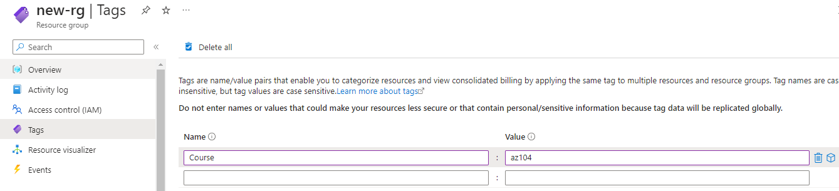

**TAG CREATED FOR THE RESOURCE**

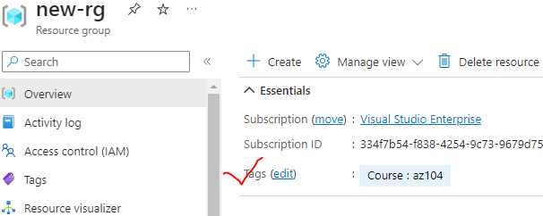

**KEY POINTS ABOUT RESOURCE TAGS**

* TAG STRUCTURE:
  + Tags consist of a name and a value. The name is a string, and the value can be any string or empty.
* TAG LIMITATIONS:
  + Each resource can have multiple tags, up to a **maximum of 50 tags per resource.**
  + Tag names are case-insensitive, and the tag name-value pairs must be unique within a resource.
* ASSIGNING TAGS:
  + Tags can be assigned to resources during creation or added later.
  + We can assign tags using Azure Portal, Azure PowerShell, Azure CLI, or Azure Resource Manager templates.
* MANAGING TAGS:
  + We can manage and view tags for resources through the Azure Portal, Azure PowerShell, Azure CLI, Azure Resource Manager templates, or Azure Management APIs.
  + Tags can also be used for filtering, organizing, and querying resources.
* COST MANAGEMENT:
  + By assigning tags to resources, we can track and manage costs associated with those resources.
  + Azure Cost Management + Billing provides reporting and analysis capabilities based on resource tags.
* POLICY ENFORCEMENT:
  + Azure Policy allows us to define policies based on tags to enforce compliance and governance rules.
  + We can use policies to ensure resources have specific tags assigned or to restrict resource creation based on tags.

#### COST MANAGEMENT ON TAGS

## GOVERNANCE AND COMPLIANCE

### AZURE SUPPORT PLANS

* URL : <https://azure.microsoft.com/en-us/support/plans>

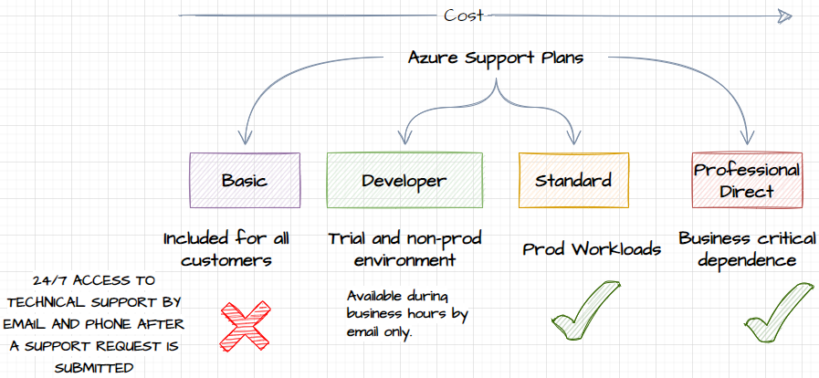

### AZURE SERVICE LEVEL AGGREMENT

* Azure provides Service Level Agreements (SLAs) to ensure a certain level of service availability and performance for its customers.
* SLAs outline the commitments and guarantees that Microsoft Azure makes regarding the reliability and performance of its services.
* URL: <https://www.microsoft.com/licensing/docs/view/Service-Level-Agreements-SLA-for-Online-Services?lang=1>

#### MONTHLY UPTIME



* If Microsoft unable to give the Monthly uptime as mentioned in the SLA of a given service for example in case of VM the following Service Levels and Service Credits are applicable to Customer’s use of Virtual Machines deployed across two or more Availability Zones in the same region:

| Uptime Percentage | Service Credit |
| --- | --- |
| < 99.99% | 10% |
| < 99% | 25% |
| < 95% | 100% |

### SERVICES IN PREVIEW

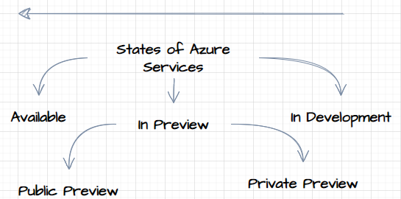

|  |  |
| --- | --- |
| * PRIVATE PREVIEW   + **Private preview is an early access program for select customers who are invited to test and provide feedback on new Azure services or features that are still in development.**   + These previews are typically limited to a smaller group of customers who have expressed interest or meet specific criteria.   + During the private preview, Microsoft actively seeks feedback to understand the usability, performance, and functionality of the service before making it generally available. * PUBLIC PREVIEW   + Public preview, also known as "preview" or "beta," is a broader release of a new Azure service or feature to a larger audience.   + It allows customers to try out the service and provide feedback to help Microsoft refine and improve it before it reaches general availability.   + Public previews are open to all Azure customers, and customers can opt to use and test the service in their own environments. |  |

* It's important to note that services in preview may still have limitations, known issues, or frequent updates as they are still being refined based on customer feedback. Those services will have no SLA associated with it, hence not recommended to be used on PROD
* **To participate in private or public previews, customers can typically register their interest through the Azure portal or by following specific instructions provided by Microsoft for the respective service or feature.**

### MICROSOFT CLOUD ADOPTION FRAMEWORK

* <https://learn.microsoft.com/en-us/azure/cloud-adoption-framework/overview>
* **The Microsoft Cloud Adoption Framework (CAF) is a set of guidance and best practices provided by Microsoft to help organizations plan, implement, and govern their cloud adoption journey**. It offers a structured approach and framework to ensure a successful and well-managed transition to the cloud.
* The CAF provides a comprehensive set of documentation, tools, and resources that cover various aspects of cloud adoption, including strategy, planning, readiness, migration, and ongoing operations.
* It helps organizations align their business goals and technical requirements with the capabilities and benefits of the Microsoft Azure cloud platform.

**KEY COMPONENTS OF THE MICROSOFT CLOUD ADOPTION FRAMEWORK:**

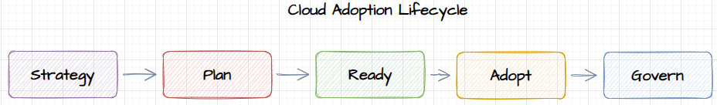

* STRATEGY
  + The CAF helps organizations define their cloud adoption strategy by considering business goals, compliance requirements, security, governance, and cost management.
* PLAN
  + It provides guidance on creating a detailed roadmap and project plan for migrating workloads, applications, and data to Azure.
  + This includes assessing current IT assets, identifying dependencies, and prioritizing migrations.
* READY
  + The CAF helps organizations prepare their IT environment, resources, and teams for cloud adoption.
  + It covers areas like training, skills development, establishing governance policies, and setting up cloud management tools.
* ADOPT
  + This phase focuses on executing the migration plan, carrying out workload assessments, performing data migration, and deploying applications and services in Azure.
  + It provides guidance on using Azure services effectively and optimizing workloads for the cloud.
* GOVERN
  + The CAF emphasizes the importance of ongoing governance and management of cloud resources.
  + It covers topics like monitoring, security, compliance, cost optimization, and establishing operational processes.

### SERVICE TRUST PORTAL

* The Service Trust Portal is a Microsoft Azure website that provides customers with information and resources related to the privacy, compliance, and security of Microsoft cloud services.
* It is designed to help customers understand how Microsoft implements and maintains security, privacy, and compliance controls to protect customer data.

FEATURES AND INFORMATION AVAILABLE ON THE SERVICE TRUST PORTAL:

* COMPLIANCE DOCUMENTATION
  + The portal provides access to compliance-related documentation, including audit reports, certifications, and attestations for Microsoft cloud services.
  + This includes information on compliance with standards such as ISO, SOC, GDPR, HIPAA, and more.
* PRIVACY CONTROLS
  + It offers information on how Microsoft handles and protects customer data, including privacy controls, data retention policies, and data subject requests.
  + This helps customers understand the privacy commitments and practices of Microsoft cloud services.
* SECURITY BASELINES
  + The portal includes security baselines and best practices for securing Azure services and infrastructure.
  + It provides guidance on security controls, threat protection, data encryption, identity and access management, and more.
* RISK ASSESSMENTS
  + Customers can find information on risk assessments, threat intelligence, and incident response capabilities of Microsoft cloud services.
  + This helps customers assess the security posture of the services they are using or planning to use.
* The Service Trust Portal is a valuable resource for customers who need to understand the security, privacy, and compliance aspects of Microsoft cloud services. It enables organizations to assess the suitability of Microsoft cloud services for their specific regulatory and compliance requirements.

### MOVING RESOURCES ACROSS RESOURCE GROUPS

* In Azure, we can move resources across resource groups using the **Azure Portal, Azure PowerShell, Azure CLI, or Azure Resource Manager templates**. Here's how you can perform this task using each method:

Azure Portal:

1. Open the Azure Portal and navigate to the resource you want to move.
2. Select "Move" from the resource's menu.
3. Choose the "Move to another resource group" option.
4. Select the target resource group and click "OK" to initiate the move.

Azure PowerShell:

1. Open Azure PowerShell and connect to your Azure account.
2. Use the Get-AzResource cmdlet to retrieve the resource you want to move.
3. Use the Move-AzResource cmdlet to move the resource to the target resource group.  
   Example: Move-AzResource -ResourceId <resourceId> -DestinationResourceGroupName <targetResourceGroup>

Azure CLI:

1. Open Azure CLI and sign in to your Azure account.
2. Use the az resource show command to get the details of the resource you want to move.
3. Use the az resource move command to move the resource to the target resource group.  
   Example: az resource move --ids <resourceId> --destination-group <targetResourceGroup>

### MOVING RESOURCES ACROSS SUBSCRIPTIONS

* We can move resources across subscriptions using the Azure Portal or Azure PowerShell.

USING AZURE PORTAL

* Open the Azure Portal and navigate to the resource you want to move.
* Select "Move" from the resource's menu.

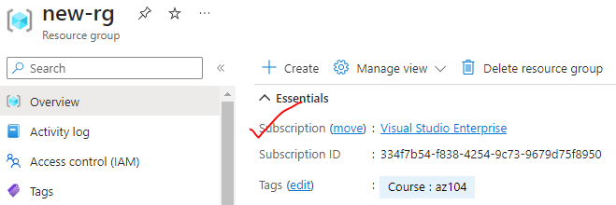

* Choose the "Move to another subscription" option.
* Select the target subscription and click "OK" to initiate the move.

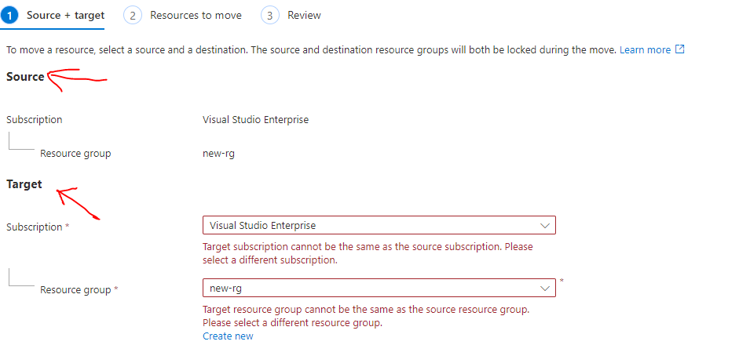

AZURE POWERSHELL

1. Open Azure PowerShell and connect to your Azure account.
2. Use the Get-AzResource cmdlet to retrieve the resource you want to move.
3. Use the Move-AzResource cmdlet to move the resource to the target subscription.  
   Example: Move-AzResource -ResourceId <resourceId> -DestinationSubscriptionId <targetSubscriptionId>

WHEN MOVING RESOURCES ACROSS SUBSCRIPTIONS, THERE ARE A FEW IMPORTANT CONSIDERATIONS:

* Permissions:
  + We need appropriate permissions in both the source and target subscriptions to perform the move operation.
* Limitations:
  + Not all resources can be moved across subscriptions.
  + Some resources, **like virtual networks and storage accounts**, have limitations or dependencies that may prevent the move.
* Resource Dependencies:
  + When moving resources with dependencies, we may need to move related resources as well.
  + **For example, if you're moving a virtual machine, we might need to move its associated network interface and storage account.**
* Resource Group: Moving a resource to another subscription may require moving its associated resource group as well. Make sure to consider the impact on other resources in the same resource group.

### LOCKING RESOURCES

* In Azure, resource locks are a feature that allows us to **prevent accidental deletion or modification of critical resources.**
* By applying a lock to a resource or resource group, we can ensure that it cannot be deleted or modified without explicit permission. This helps in maintaining the integrity and stability of important resources.

HERE ARE A FEW KEY POINTS ABOUT RESOURCE LOCKS IN AZURE:

* TYPES OF LOCKS: There are two types of locks you can apply to resources:
  + Delete Lock (CanNotDelete): This lock prevents the resource from being deleted, but it allows other modifications.
  + Read-Only Lock(ReadOnly): This lock makes the resource read-only, preventing both deletion and modifications.
* SCOPE:
  + We can apply locks at the resource group level or at the individual resource level.
  + **Applying a lock at the resource group level automatically applies it to all resources within that group**.
* LOCK HIERARCHY:
  + Locks have a hierarchical relationship, meaning a lock applied at a parent level (resource group) is inherited by child resources unless overridden.
  + For example – the Locks on resource group level will apply the lock to all the resources in the resource group. Similarly the locks on subscription level will apply the lock to all the resources in that subscription

#### SETTING UP RESOURCE LOCK

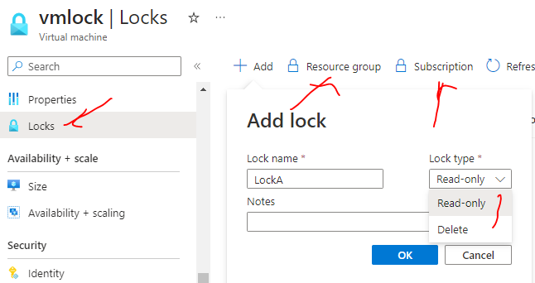

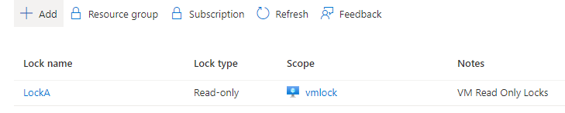

* **As “ReadOnly“ locks has been applied to the VM – we cannot perform any operation or modify any of the property of the VM.**

#### LOCKS AND MOVING RESOURCES

* **If the resource has lock we still have the ability to move the resource across the resource groups.**
* **If applied a lock at the resource group level, then the lock will be inherited to the resources in the resource group. If we try to move the resource to different resource group – then we cannot move the resource because we are changing the properties of the resource group.**
* if we lock the destination resource group even then we can't move the resources to the destination resource group

### AZURE POLICY

* Azure Policy Service is a governance service in Microsoft Azure that allows us to enforce and monitor compliance with organizational standards and best practices across your Azure environment.
* It provides a centralized way to define, assign, and enforce policies that govern resource configurations and behaviors.  
    
  Here are some key features and capabilities of Azure Policy Service:
* Policy definition: Azure Policy allows you to define policies using JSON-based rules that specify the desired state and behavior of Azure resources. Policies can cover a wide range of aspects, such as resource properties, tagging, access control, network security, and more.
* Policy assignment: Once policies are defined, you can assign them to Azure subscriptions, resource groups, or management groups. This allows you to apply policies at different scopes, depending on your governance requirements.
* Compliance evaluation: Azure Policy continuously evaluates resources against assigned policies and provides compliance results. It helps identify resources that are non-compliant, allowing you to take corrective actions to bring them into compliance.
* Policy enforcement: Azure Policy can enforce compliance by blocking the creation or modification of resources that violate policy rules. It can also trigger notifications or remediation actions to rectify non-compliant resources.
* Built-in and custom policies: Azure Policy offers a range of built-in policies that cover common governance scenarios. Additionally, you can create custom policies tailored to your specific requirements using Azure Policy's JSON-based policy definition language.
* Integration with Azure DevOps and CI/CD pipelines: Azure Policy integrates with Azure DevOps and CI/CD pipelines, enabling you to include policy validation as part of your deployment and release processes.  
    
  Azure Policy Service helps you maintain control and enforce governance across your Azure environment by providing a mechanism to define, assign, and enforce policies. It promotes best practices, improves security, and ensures compliance with organizational standards and regulatory requirements.

### MANAGEMENT GROUP

* In Azure, Management Groups are a hierarchical organizational construct that allow us to manage and govern resources across multiple Azure subscriptions.
* Management Groups provide a way to apply policies, access control, and governance at scale by creating a hierarchy of groups.